*Use the information in Chapter 48 (p.1045-1047) to complete the following questions. You may want to view Bozeman’s podcast* [*Nervous System*](http://www.bozemanscience.com/nervous-system/) *for support.*

**Concept 48.1 Neuron organization and structure reflect function in information transfer**

Use the diagram below to summarize how organisms with a nervous system process information. Explain why this an example of long distance signaling.

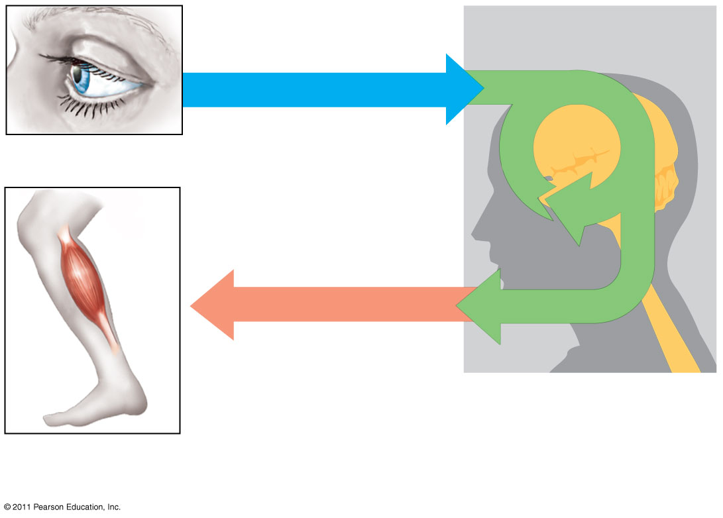

Use Figure 48.4 (p.1047) to draw and label the basic anatomy of two communicating neurons and explain how the propagation of an action potential progresses from one neuron to another.

**Concept 48.3 Action potentials are the signals conducted by axons**

Label and discuss the significance of the Schwann cells/myelin sheath and nodes of Ranvier in facilitating cell communication between neurons.

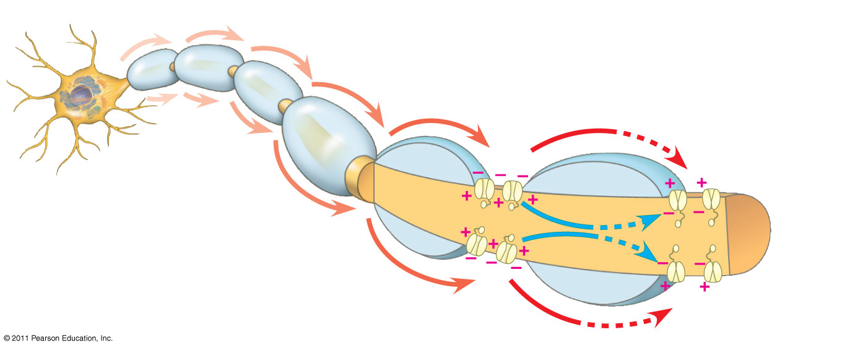

**Concept 48.4 Neurons communicate with other cells at synapses**

Use the diagrams below to discuss how excitatory postsynaptic potentials (EPSP) differ from inhibitory postsynaptic potentials (IPSP).

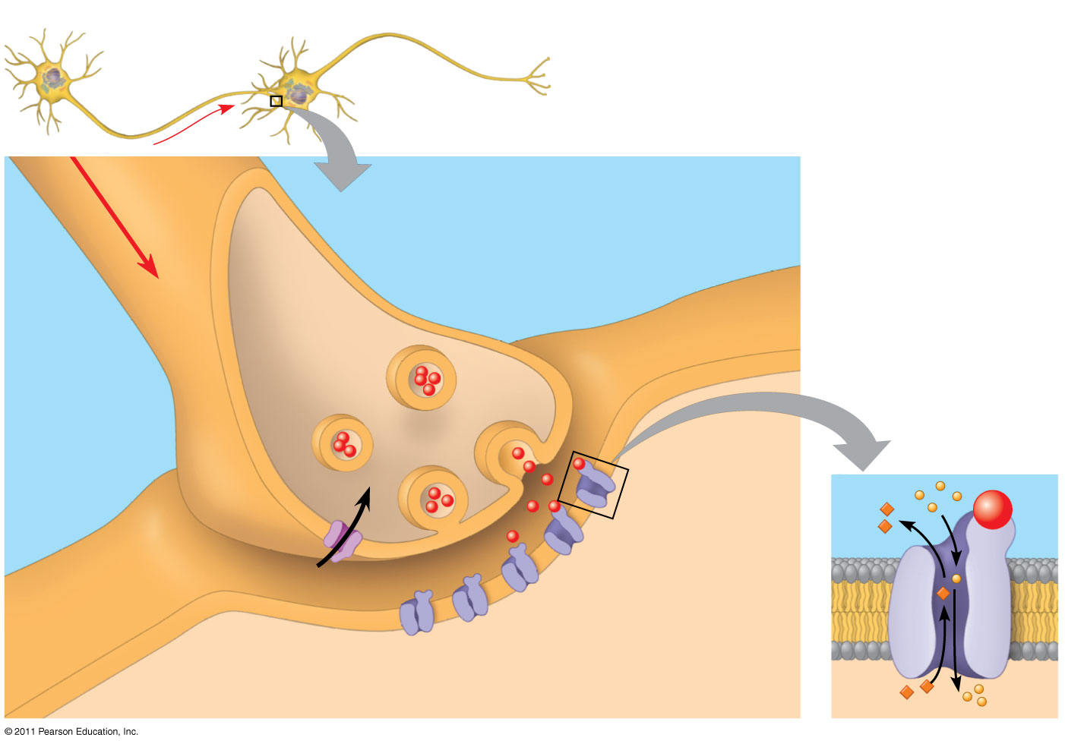

Complete the table below with information about the major neurotransmitters used in postsynaptic signaling.

|  |  |  |  |
| --- | --- | --- | --- |
| **Neurotransmitter** | **Inhibitory** | **Excitatory** | **Effect on Body** |
| Acetylcholine |  |  |  |
| GABA |  |  |  |
| Norepinephrine |  |  |  |
| Dopamine |  |  |  |
| Serotonin |  |  |  |
| Endorphins |  |  |  |